Cas9-based germline mutagenesis in Tetrahymena beta-version 160610

1) Construction of Cas9 target vector

1-1) Choose any 20-nt sequence proceeding 5’-NGG-3’ (PAM sequence)

5’-NNNNNNNNNNNNNNNNNNNNNGG-3’ (target sequence is underlined)

Note: Cas9 cuts the bond between the bases complementary to the 17th and 18th nucleotides of the target and deletions normally occur around this cleavage site. Avoid XhoI site (5’-CTCGAG-3’) for target sequence (this is very rare anyhow) because XhoI will be used to cut out the final construct from the vector backbone. Alternatively, you can cut the vector with KpnI and SacII in the step 2-1.

1-2) Order the following oligo:

5’-GCTTTATAAGATTTCAAAAACTTTAATAGTTGNNNNNNNNNNNNNNNNNNNNGTTTTAGAGCTAGAAATAGCAAG-3’

(underlined sequences are for recombination by Gibson assembly system)

examples:
TPB2_T1_GA: GCTTTATAAGATTTCAAAAACTTTAATAGTTGCCTGTTGTAATGTATGACGAGTTTTAGAGCTAGAAATAGCAAG
TPB2_T3_GA: GCTTTATAAGATTTCAAAAACTTTAATAGTTGGACAAAAAAGAACTTATGAGTTTTAGAGCTAGAAATAGCAAG

Note: G at -1 position is not necessary if your target starts with G (like in the “TPB2_T3_GA” above). This G is only necessary for the efficient transcription from the U6 promoter by pol III (though this is not confirmed in Tetrahymena). Presence of this non-target G may slightly reduce Cas9-mediated cleavage (but in the above example, TPB2_T1_GA and TPB2_T3_GA showed similar efficiency). So the best is to find a target starting from G and is followed by NGG but finding such target at a preferred site of Tetrahymena genome is probably difficult.
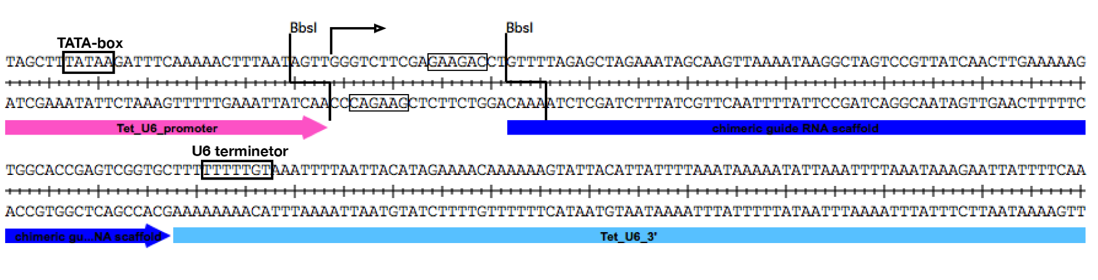

1-3) Preparation of pC9T vector

Mix the followings in a 1.5 mL tube
15 µL pC9T-HF4 vector
5 µL 10x NEB2
1.5 µL BbsI
28.5 µL MonoQ water

Incubate at 37°C for >3hr to overnight
Add 0.5 µL BbsI and incubate at 37°C for additional >1 hr
Clean-up DNA with Qiagen PCR clean-up kit
Elute DNA with 50 µL MonoQ water

1-5) Ligation & transformation

Mix the followings in a 0.5 mL tube
1 µL 100 µM oligo DNA
1 µL BbsI-digested pC9T-HF4 vector (from 1-3)
2 µL 2x Gibson Assembly mix (NEB)

Incubate at 50°C for 30 min (with a PCR machine with heated lid)
Use 2 µL of the reaction to transform 200 µL of DH5alpha and select on an Amp+ LB plate
Mini-prep a few colonies and check target insertion by sequencing using gRNA_SeqFW (5’- TAGTAAGTTAAAAATTCAGTCATTCAGC-3’, you can find it in the common primer box).

Note: NEBuilder® HiFi DNA Assembly Master Mix probably gives better results (and cheaper): lower mutation rate

2) Mutagenesis

2-1) Cut pC9T-target vector with XhoI

Mix the followings in a 1.5 mL tube (for 2 transformations)
15 µL pC9T-target plasmid (mini-prep from ~2 mL LB culture)
28 µL MonoQ water
5 µL 10x Takara K buffer (or 10x NEB 2.1 buffer)
2 µL XhoI

Incubate at 37°C for >1 hr (to overnight)
Clean-up DNA with Qiagen PCR clean-up kit
Elute DNA with 50 µL MonoQ water

2-2) Perform transformation according to “Somatic transformation Ver2” use 10-20 µL of DNA for a transformation

<Method 1>
2-3) Select transformed cells in 1x SPP containing 100 µg/mL paromomycin and 1 µg/mL CdCl₂. Make serial dilutions of culture (x1, x1/10, and 1/50 for example).

2-4) Choose 24 cell lines from 96 well plate(s) having growing cells in less than half of the wells.

2-5) Culture them in 1 mL 1 xSPP w/o paromomycin and CdCl₂ (in 24 well plate) at 30°C for 1-2 days

2-6) Make replica plate and store at RT

2-7) From the original plate (make in 2-4), extract genomic DNA (using NucleoSpin kit)

2-8) Amplify MIC target locus by PCR (one primer must be in IES)

2-9) Check DNA sequence around the target sequence from both direction (using upstream and downstream primers)

<Method 2>
2-3) Select cells with 100 µg/mL paromomycin without cadmium

2-4) Perform phenotypic assortment till cells grow in ~ 10-20 mg/mL paromomycin

2-5) Take ~ 5 µL well growing culture to 1 mL 1x SPP and incubate at 30°C for overnight

2-6) Add 1 µL of 1 mg/mL CdCl₂, mix well and incubate at 30°C for 6 hrs

2-7) Isolate ~48 single cells into drops and culture at 30°C for 1-2 days

2-8) Perform the steps 2-5 -2-9 in “Method 1

Comments/Ideas:

a) Method 1 works well for B2086 but not for CU427, CU428 and SB210, at least when I tried to mutate TPB2. Method2 works for CU428 (and probably also for other strains but has not been tested).

b) It would be better to include “star mating” step to make mutation in homozygous state. For example, we can implement such step between 2-5 and 2-6, isolating pairs into SPP drops, and kill star strains in paromomycin+ medium.

c) We so far only checked introduction of mutations in MIC. We do not know if a MAC copy can be also targeted by this system.

d) One of the limitations of this protocol is that distance between target sequence and the closest IES must be <10 kb because, in the step 2-9, we need to use a primer complementary to an IES for PCR. We need to find a strategy that overcomes this problem.

e) 6 hr induction in the step 2-6 in “Method 2” is determined just by educational guess. We may have to perform a time-course experiment to determine an optimal induction condition. This induction may not necessary as leaky Cas9 expression during assortment would make mutations even before the induction.

